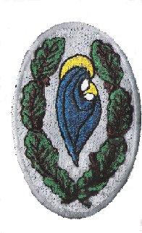
Knockmore Junior School
October 2021
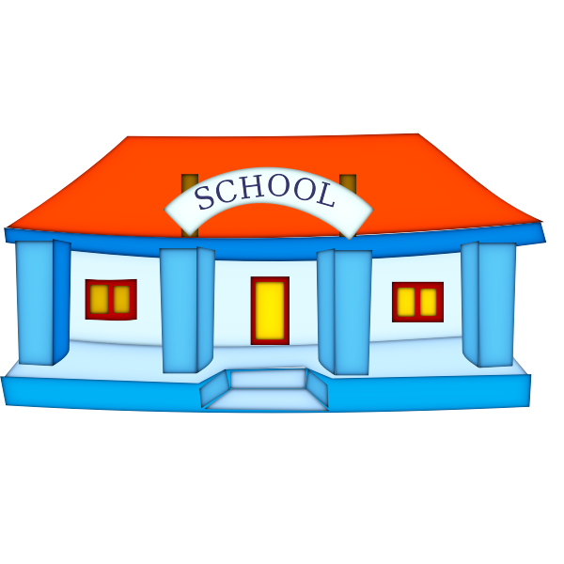
All the teachers and staff would like to thank everyone for getting behind the school and supporting our successful return. We have had a great start.
The children are really happy to be back in school and have adapted to their classrooms and routines.
Our aim is to make them happy while they continue to settle in over the next few weeks.
We also welcomed our Junior Infants. They have taken to their new school life like ducks to water!
The entry system at the gate is working well so thank you for keeping to your assigned times and for wearing face coverings.
By working together we can keep our school open, happy and safe!

SCHOOL ATTENDANCE
48 children have come to school 100% of the time in September.
Ms Hanahoe’s Garden Class achieved best attendance at 95.5% and
Ms Cooney’s 2nd Class attendance at 95.1%.
School overall attendance is at 89.5%.
Always send in a note to explain your child’s absence and complete the Return to School Declaration form on
Aladdin Connect.

KNOCKMORE ATTENDANCE DRIVE

To encourage better attendance in school we launched the KNOCKMORE ATTENDANCE DRIVE. Each day your child comes into school, they will get a raffle ticket. So the more tickets, the greater the chance of winning!
The raffle will be on Friday 22nd October, just before Mid-Term Break!

SCHOOL BOOKS

School books can be paid for at the office (please email in advance to make an appointment). Please remember that children will not receive their books until full payment is made.
We recommend that books are paid for as soon as possible so as not to delay your child’s participation in their school day.

Please note: as insurance is part of the book payment package, children who have not paid for their books will not be permitted to go on out of school trips, i.e. school tours as they are not insured.

We now have contactless payment.

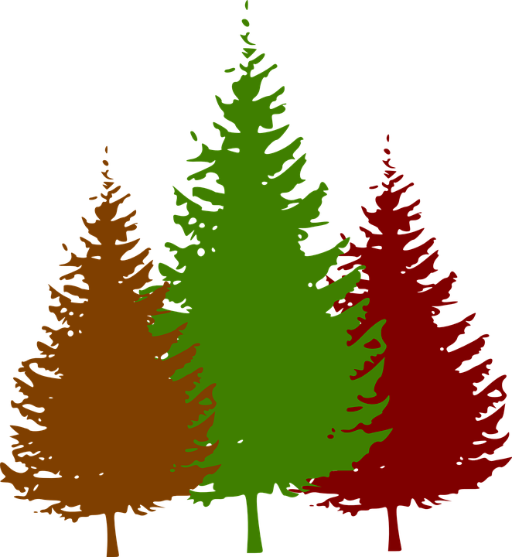
FOREST SCHOOL

Forest school has returned again this year, giving your child a deeper appreciation of nature and an understanding of the plants and animals that live all around us.
Forest school is done in conjunction with our curriculum.
The cost of this is €12 which should be paid to the class teacher.

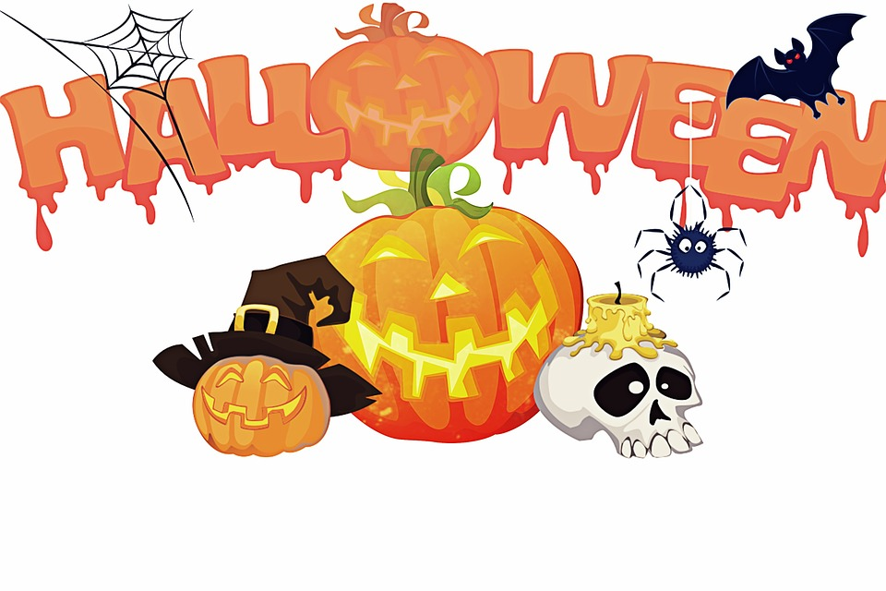
HALLOWEEN FUN DAY

This year we will have a Halloween Fun Day on Friday, 22nd October. The children can come to school in their fancy dress costumes.
Boo!

GREEN SCHOOLS
Thanks to your incredible efforts to walk, cycle and scoot to school, we were able to win our fourth Green Schools Flag for Travel!
Make sure to use our new beautiful bike and scooter parking 💚
We are now starting the theme of Biodiversity in order to achieve our fifth Green Schools Flag! 🌎

SCHOOL UNIFORMS

Please ensure your child is in their correct uniform i.e. tracksuit top and grey trousers/skirt and full tracksuit on P.E. days.
Please write your child’s name on their jumpers,coats and belongings. Children often have identical coats and jumpers, it will save on confusion! For rainy days please make sure they have their wellies, wet trousers and raincoat. Children need a set left in school.

Healthy Lunch Policy
We provide healthy and nutritious hot school lunches free of charge. We would encourage you to avail of these lunches for your child every day.
If your child has a dietary issue, please discuss it with his/her teacher.
Sugary foods, chocolate, crisps and fizzy/high-sugar drinks are not permitted in school. Children will be asked to put these in their school bags until they go home.
No peanuts please, this includes peanut butter and chocolate spread with nuts (nutella)
Please give your child a bottle of water in their school bag each day.

Holidays / Closures for 2021 / 2022
Teacher Training Day | Closing at 12 noon on Wednesday 20th October
Halloween Mid Term | Closing Friday 22nd October at 2:30pm, re-opening  Monday 1st November
Christmas Holiday | Closing Wednesday 22nd December at 11am. Reopening Thursday 6th January 2022

